КАЯК

DISCONTINUED
Freya Hoffmeister is one of only two to have circumnavigated Australia in a kayak. She is the only woman and the only unassisted paddler to have achieved this feat. Following this 2009 adventure, she is currently circumnavigating South America –the first ever to attempt this. She has numerous other spectacular kayak expeditions under her belt.
When Point 65 and Freya began designing the FREYA 18, safety, comfort, and speed were key design features. The result is stunning. Even the most experienced paddler can become frustrated with the constant bracing in the rough. The Point 65 FREYA 18 changes everything. This lightning-fast expedition kayak is designed for maximum speed when conditions get real. The FREYA 18 is designed to outrun most anything while keeping its rider safe in the cockpit through the most fearful chop, surf, wake or you name it. After hours of paddling, being safe is essential. It’s the combination of speed and stability that makes the FREYA 18 truly unique.
The FREYA 18 compiles all Freya Hoffmeister’s experiences from years of extreme long-distance expedition paddling, and the result is a kayak with speed vis-á-vis stability and comfort. It is designed in cooperation between Freya and the award-winning design engineer and avid paddler Magnus de Brito, using highly advanced hydrodynamic design technology combined with experience and extensive testing. Freya and Magnus have created a unique expedition kayak that is faster than most while comfortably stable even in the roughest conditions.
The large storage compartments are designed to hold gear for weeks of unassisted paddling. Your heaviest gear will barely slow it down – this is an ideal expedition kayak built to carry a huge

payload. The Freyas innovative integrated keel rudder gives the kayak incredible maneuverability. The retractable skeg is integrated with the rudder which increases the maneuverability and offers great tracking when winds and currents are working against you.
The Freyas deck is designed similarly to a surfski. A surfski is designed for paddling in windy conditions using a rudder. So is the Freya. It's high bow works together with the skeg balancing the kayak against weathercocking (turning upwind). The high bow is an essential design element to this end. Just as on a surfski, the large bow volume also optimizes surf performance in waves and swells. The deflective curves at the sides of the bow and in front of the cockpit keep you dry in rough conditions.
The cockpit is long and wide to enable powerful strokes through optimal legroom as well as increased comfort during entry and exit. Store heavy gear in the two large, bone dry oval hatches, lighter bags for your small essentials in the large 20cm day hatch. It comes with the integrated keel rudder and the retractable skeg, moveable centered rudder pedals in lightweight carbon.
Produced in advanced lightweight composite technology, the FREYA 18 is available as two options: Fiberglass 25kg/55lbs) and Pro Lite in carbon/kevlar (21kg/46lbs).
The FREYA 18 is available in limited edition only.

I'm glowing in the morning day light from the mountains - the sea is still dark.
Since Valparaiso/ Chile in August 2012 I was paddling around South America the new “Freya” expedition kayak, developed by Point 65 in cooperation with the designer Magnus de Brito and my own experience of many miles of remote expedition kayaking.
I will now in my home break write some personal review about the kayak, trying to be objective and not influenced by my obvious sponsorship by Point 65 ….there are a lot of common sense knowledge statements in there, but also a lot of fine tuning your “Freya” kayak you already own or plan to purchase soon.
- When it puts you off that the kayak carrying my name in fat letters you can peel them off easily – I know I am not everybody’s personal darling (and don’t even want to…) ! :-)
- This boat has a strong character – like myself….and it is unique in the wide range of available expedition sea kayaks. Don’t even think an at the first glance similar looking boat has the similar features. I am happy to compare for you any other available brand’s model and tell you why mine is better!
- You like the most beautiful, sexy looking piece ever with outstanding lines, not able to be mixed up with any other model on the market? The “Freya” has it… :-)
- You like a kayak with large storage capacity? I can easily carry food for way more than four weeks and water for more than twelve days, plus all the rest of my gear I think I need to carry around. You just need to be able to handle the heavy barge then at least at the beginning until you eat and drink your way through the load. Any other expedition kayak I paddled so far can carry way less stuff. Even in front of the footrest I can store 4 x 4 liters of water, if needed…(with my body length of 1,77 m, Peter with 1,95 m having the seat and footrest extended to the max still can take two bags there)
- Yes, you should not be a too short, too weak person to paddle this boat, though the range of the seat adjustment and footrest adjustment allows people down to maybe 1,60 m to be able to paddle the kayak and to find a good position on paddling with free knees and on locking the legs in case you need to roll. But a full load of over 100 kg may be tough to handle by a short fragile woman. I am just an average size, average strength (compared to males…) , am perfectly happy with the relation of my size and the kayak and can handle it even fully loaded!
- You like a fast kayak, still solid stable and tracking well straight with a now perfect rudder system? Here we go…it is fast as hell with the round hull shape and sharp bow and very little rocker, surfing empty like a flash while easy to keep stable in big waves and straight with the most efficient rudder hanging always *in* the water, and it is with those qualities simply running efficient if you have a heavy load – all I want on my expeditions. It is not a typical beginner kayak though, but possible, and if you teach a beginner in this kayak, he/ she will at least be able to learn how to paddle correctly with the features below.
- You like non-leaking and simply to handle hatches and lids? The regular solid oval rubber hatches are never leaking once put on straight, They are very easy to handle compared to some other fancy looking but at the end all leaking or fumbling hatch closure systems. My own kayak is eventually produced well with very few spots to sand or other ugly spots like non-laminated screw hats inside. They are getting close to the perfectly manufactured kayak (which I NEVER had on any other kayak…) If your day hatch has still such a stiff lightweight lit, ask your dealer for a solid rubber one. They are much better and locking solidly, although a few grams more heavy. Who cares?
Paddling picture from the escort boat into the river.
- I would now (after my student’s learning phase…) never paddle a skeg only kayak for an expedition or even a simple day touring, as it is a waste of energy to do correction strokes with the paddle. Why should I not rather just press slightly my either tip toes to go around a corner instead of taking speed out of my pace to use the paddle for directional control or to edge my kayak? I see no reason…besides kayak teachers have something to teach and it may be fun to learn. But it is not efficient, neither on surfing waves, nor on fast paddling, nor on maneuvering your kayak through narrow slots. And efficiency is a BIG word for me on a kayak trip…and it may end up into more safety…
- Also, any other rudder system will break sooner or later, pulled up or being released on a rough surf landing. And if you maybe have even to do a roll with potential ground touch, or the kayak is later tumbling around in the back surge or surf after exiting before you are eventually able to control it, it is also likely to break. Other similar looking rudder systems like the one from epic are way too fragile, wearing out quickly and breaking the fin off easy. My rudder system is (after some teething problems…) solid and survived even my endless Pororoca surf at night with the nylon blade only marginal bent. I could form it with some pressure just back to the old shape. On any other ugly surf landing I did the same, if the blade got a bit bent, but it never broke!!! Neither did the whole system dissolve. Ok, every few days I have to tighten the screws on the small bottom bar holding the rudder foot on place. Some Locktite may fix the issue. And you may need to check after long heavy use the screws holding the pole of the rudder foot after you took the rudder off. But this may not even be necessary for normal use.
- You should look *not* for a kayak with those fat thigh supports sticking out in the way where you should drive your legs up and down while paddling…the knee lock under the cockpit rim in case of a necessary roll is good enough. Unfortunately a normal sea kayaker is still thinking he needs to spread out and to lock his knees all the time while paddling…kayak racer and surfski people don’t either, and the latter paddle in sometimes bigger seas than sea kayakers do…I hung out enough with racing people to see the difference. These thighs support pieces are also in the way on a quick entry or exit. Unfortunately there are very few so called “fast fitness kayaks” with expedition ambitions, having a sharp vertical bow and thinking they are matching this class just trying to look the same in the hull shape. As they are mostly outfitted with those surplus pieces, the result is that few sea kayakers are learning and eventually are able to paddle an efficient body rotating, core paddling style as they obviously can’t use their legs with them being safely locked away all the time. You may slightly get around this issue by keeping your legs off the thigh braces and still moving them up and down in the range your kayak does allow. But it will never be working well.
- The same goes for the footrests – as you should drive your legs, keeping them close together to support your good core paddling style, you will meed a solid foot bar like in the “Freya” kayak reaching all across the hull, with the directional control paddles attached on the top, instead of those tiny rests attached to the sides of the hull, hurting not only your feet on a long paddling day, not being able to find a variation of comfortable positions, but also forcing you to spread your knees. Even worse is the strange system of some Canadian manufacturer where the tiny footrests at the sides are mounted on sliding bars and are even meant to be moving to be able to turn the rudder…if you now try to drive your legs somehow to assist a good core paddling style, you are continuously moving the rudder like a fish tail…maybe this propels you along a bit faster? :-)
- All deck lines, toggles and fittings are made and placed well, you can easy add a Zölzer deck net on the front deck and a triangle cut one on the stern for your helmet, see my own kayak pictures. I always have such nets on my kayak deck. And you should add a double running bow line with a sliding knot and solid snap link for multi purpose use. I mostly drag my emptied kayak up the beach on the bow line clipped to the toggle, having in this way two attachment points on the last fitting and on the toggle to hold the weight. I also use the bow line as a life line on paddling to clip myself via the spray deck or PFD to the kayak on ANY conditions. And you may like the bow line simply to park your kayak afloat somewhere, and and and…
- The backrest they put in is not too bad, but quite high. I personally prefer a smaller soft one Back Band 2 from Snapdragon.
- The flat seat in the production line you can also live with to a certain degree of hard usage. I have a more solid one built in my expedition version which is hung up on two rails at the sides of the hull and not sitting on one bottom rail only.
-The cockpit rim is mostly a bit sharp inside where you like to grab the kayak straddled to pull it up the beach backwards, but you can sand the spot to soften.
Overall – I don’t like to paddle any other kayak on any length any more! Lengthy expedition, weekend or short day trip – this is my kayak!
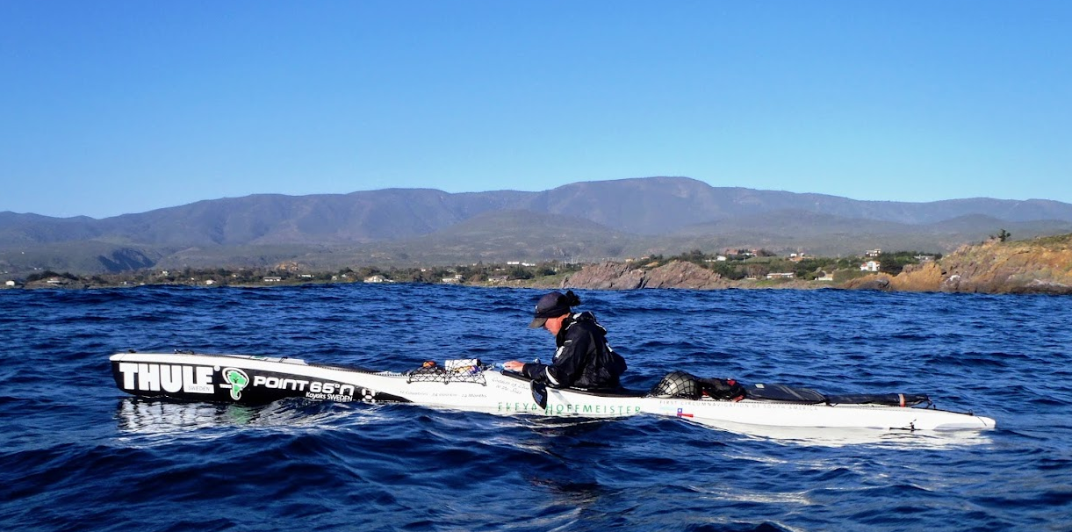
My beautiful boat!

